Assignment 12 (S-520)

FNU Anirudh

December 10, 2015

# Solution 1

Successfull Flight Maneuver should depend on skill and chance, so for a particular candidate, performance on next flight maneuver will be less than his previous performance because we can't expect chance factor(random) to be equally good on his next manuever even though skills are same.This can be attributed to Regression to Mean.

# Solution 2

x<- c(-0.2,-0.9,-0.4,0.6,0.4)  
y<- c(0.4,-0.3,-0.3,0.5,1.1)  
# a) Pearson's Correlation Coefficient is given by  
print("Pearson's Correlation Coefficient is =")

## [1] "Pearson's Correlation Coefficient is ="

r=cor(x,y)  
r

## [1] 0.8243559

# b)  
plot(x,y)  
# Predict y from x  
slope = r *(sd(y) / sd(x))  
intercept = mean(y) - (slope * mean(x))  
predictions = intercept + slope*x  
SSE = sum((y - predictions)^2)  
abline(intercept, slope, col="red")

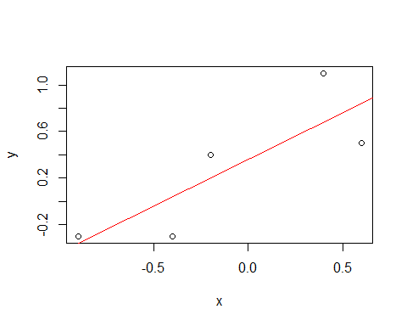

# Equation of line y=intercept + slope*x  
# In this case, Equation is y=0.36 + 0.80x  
# c)  
# Predict x from y  
plot(y,x)  
slope2 = r *(sd(x) / sd(y))  
intercept2 = mean(x) - (slope * mean(y))  
predictions2 = intercept + slope*y  
SSE2 = sum((x - predictions)^2)  
abline(intercept2, slope2, col="blue")

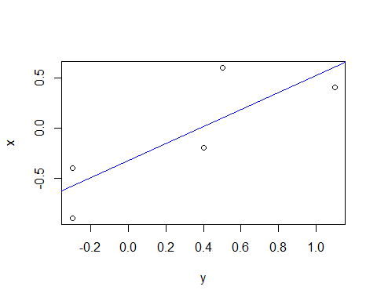

# Equation of line here is x=intercept1 + slope2* y  
# x=-0.32 + 0.84y  
  
# d) Scatter Plot  
source('C:/Stats/Assignment 11/binorm.R')  
plot(x,y)  
abline(intercept, slope, col="red")  
abline(intercept2, slope2, col="blue")

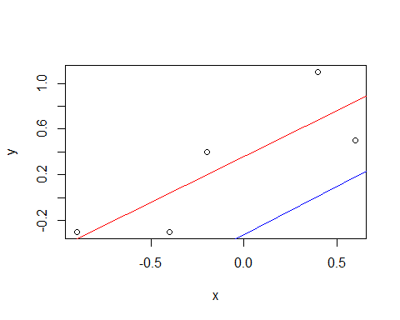

binorm.scatter(cbind(x, y))  
abline(intercept, slope, col="red")  
abline(intercept2, slope2, col="blue")

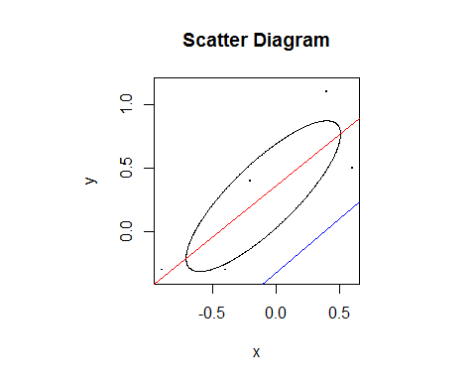

# Solution 3

sister<- c(69,64,65,63,65,62,65,64,66,59,62)  
brother<- c(71,68,66,67,70,71,70,73,72,65,66)  
all<- c(sister,brother)  
mb=mean(brother)  
ms=mean(sister)  
mall=mean(all)  
n=length(sister)  
sx=sum((sister-ms)^2)/(n-1)  
sy=sum((brother-mb)^2)/(n-1)  
r=cor(sister,brother)  
r2=r^2  
# a) The sample coefficient of determination, the proportion of  
# variables "explained" by simple linear regression is square of   
# correlation coefficent  
r2

## [1] 0.3114251

SST = sy*(n-1)  
SSR = r2 *SST  
SSE=(1-r2)*SST  
df1=1  
df2=9  
msr=r2*SST  
mse=SSE/df2  
f=(n-2)*r2/(1-r2)  
1-pf(f,df1,df2)

## [1] 0.07441681

# b) Ho:beta>0   
# Since p-value>0.05, we fail to reject Null Hypothesis hence we  
# cannot say that knowing sister's height helps one predict her  
# brother's height.  
# c)  
syy=sqrt(sy)  
sxx=sqrt(sx)  
beta1=r*(syy/sxx)  
gt=qt(0.95,df2)  
se=((1-r2)*sy)/((n-2)*sx)  
print("Confidence Interval is=")

## [1] "Confidence Interval is="

lower=beta1- (gt*sqrt(se))  
upper=beta1+ (gt*sqrt(se))  
lower

## [1] 0.05401643

upper

## [1] 1.127802

# d) Given L=0.1

# Solution 4

# Solution 5

ext=read.table('C:/Stats/Assignment 12/examanxiety.txt',header = TRUE)  
exam<-ext$Exam  
anxiety<-ext$Anxiety  
b = cor(exam, anxiety) * sd(exam) / sd(anxiety)  
a = mean(exam) - b * mean(anxiety)  
plot(anxiety, exam,main="Plot of Exam Vs Anxiety",xlab="Anxiety",ylab="Exam")  
abline(a, b, col="red")

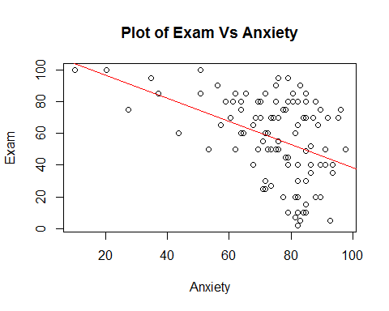

# Equation of line is y=a+bx  
# Exam=111-0.73* Anxiety  
  
# b)  
fit<-lm(Exam~Anxiety,data = ext)  
par(mfrow=c(2,2),mar=c(4,4,2,1))  
# Plot to check for Homodeskascity, Normality of errors, Independence  
# of errors  
plot(fit)

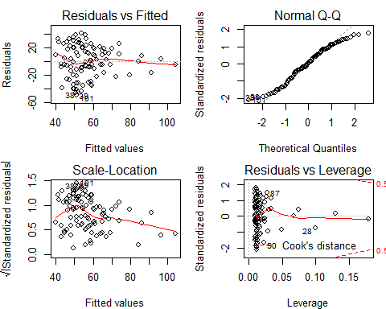

# From Plot, we conculde that out of all assumptions only assumption  
# about normality of error seems true.  
  
# c)  
# Suppose X and Y are bivariate normal.Then given a specific value  
# of X, Y follows normal distribution.  
# cor(anxiety,exam)=-0.439 correlation is negative hence we should   
# not use bivariate normal and instead fit an ellipse in scatter plot  
# ellipse won't fit density but will be cross like shape.

# Solution 6

fit1<-lm(Exam~Anxiety+Revise+Gender,data=ext)  
fit2<-lm(Exam~Anxiety+Revise,data=ext)  
summary(fit1)

##   
## Call:  
## lm(formula = Exam ~ Anxiety + Revise + Gender, data = ext)  
##   
## Residuals:  
## Min 1Q Median 3Q Max   
## -45.834 -15.029 -1.121 21.845 40.243   
##   
## Coefficients:  
## Estimate Std. Error t value Pr(>|t|)   
## (Intercept) 89.7932 17.8090 5.042 2.08e-06 ***  
## Anxiety -0.5202 0.1973 -2.636 0.00974 **   
## Revise 0.2746 0.1703 1.612 0.11009   
## GenderMale 0.5587 4.6497 0.120 0.90460   
## ---  
## Signif. codes: 0 '***' 0.001 '**' 0.01 '*' 0.05 '.' 0.1 ' ' 1  
##   
## Residual standard error: 23.34 on 99 degrees of freedom  
## Multiple R-squared: 0.214, Adjusted R-squared: 0.1902   
## F-statistic: 8.987 on 3 and 99 DF, p-value: 2.544e-05

summary(fit2)

##   
## Call:  
## lm(formula = Exam ~ Anxiety + Revise, data = ext)  
##   
## Residuals:  
## Min 1Q Median 3Q Max   
## -45.591 -14.763 -1.397 21.831 40.505   
##   
## Coefficients:  
## Estimate Std. Error t value Pr(>|t|)   
## (Intercept) 90.3422 17.1279 5.275 7.72e-07 ***  
## Anxiety -0.5230 0.1950 -2.682 0.00857 **   
## Revise 0.2717 0.1678 1.619 0.10849   
## ---  
## Signif. codes: 0 '***' 0.001 '**' 0.01 '*' 0.05 '.' 0.1 ' ' 1  
##   
## Residual standard error: 23.23 on 100 degrees of freedom  
## Multiple R-squared: 0.2139, Adjusted R-squared: 0.1982   
## F-statistic: 13.61 on 2 and 100 DF, p-value: 5.931e-06

From above we can say that model should be Exam~ Anxiety+Revise since exam scores depend on Revision and Anxiety before the exam, Exam score has nothing to do with gender of person.R2 value decreases when Gender is included and Residual Standard error increases hence model should be Exam~Anxiety+Revise.